Date:13-07-26
Jana Malakondaiah
192424223
1.Mapping color
Code:
library(ggplot2)
ggplot(mtcars, aes(x = wt, y = mpg, color = factor(cyl))) +
geom_point(size = 3)
output:
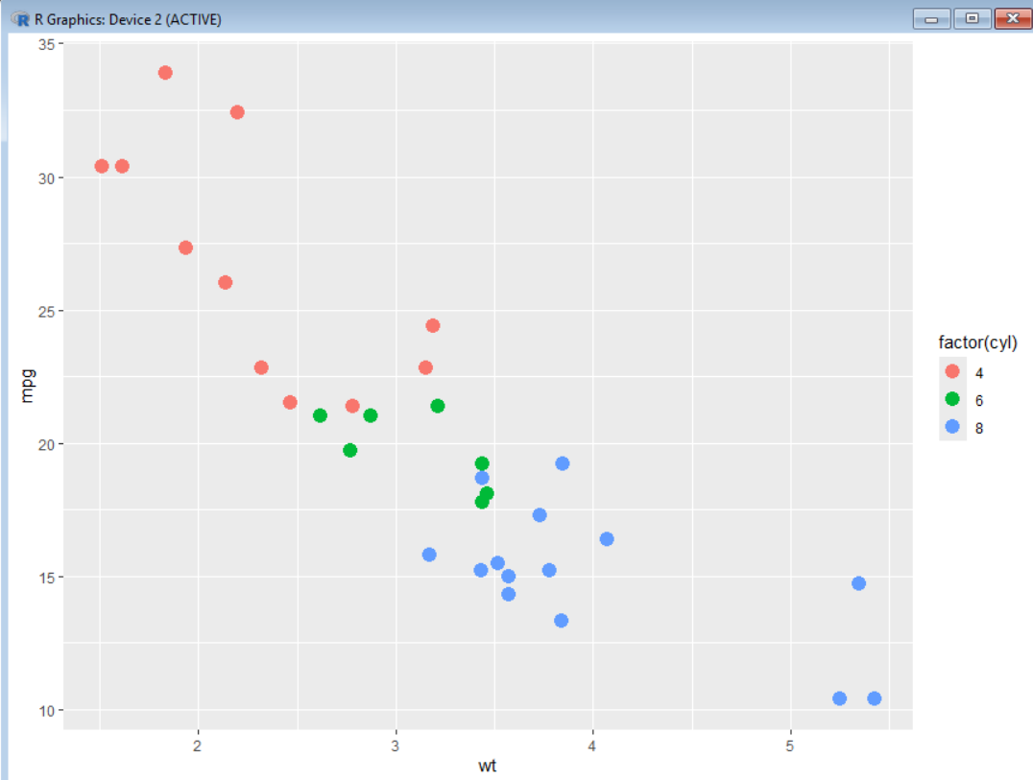
2.Continous example
Code:
library(ggplot2)
ggplot(mtcars, aes(x = wt, y = mpg, color = hp)) +
geom_point(size = 3)
output:
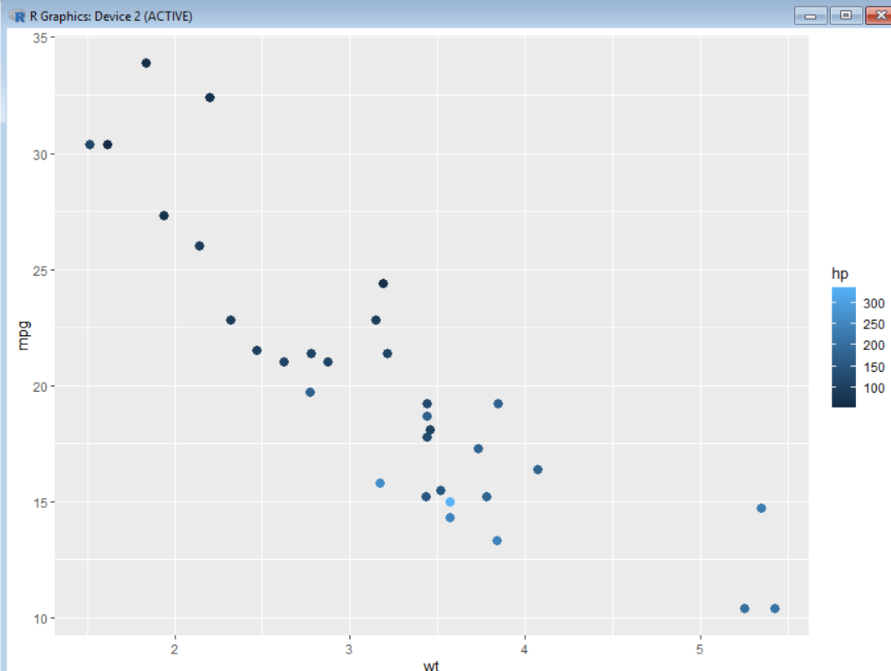
3.Categorical example
Code:
library(ggplot2)
ggplot(mtcars, aes(wt, mpg, color = factor(gear))) +
geom_point(size = 3)
output:
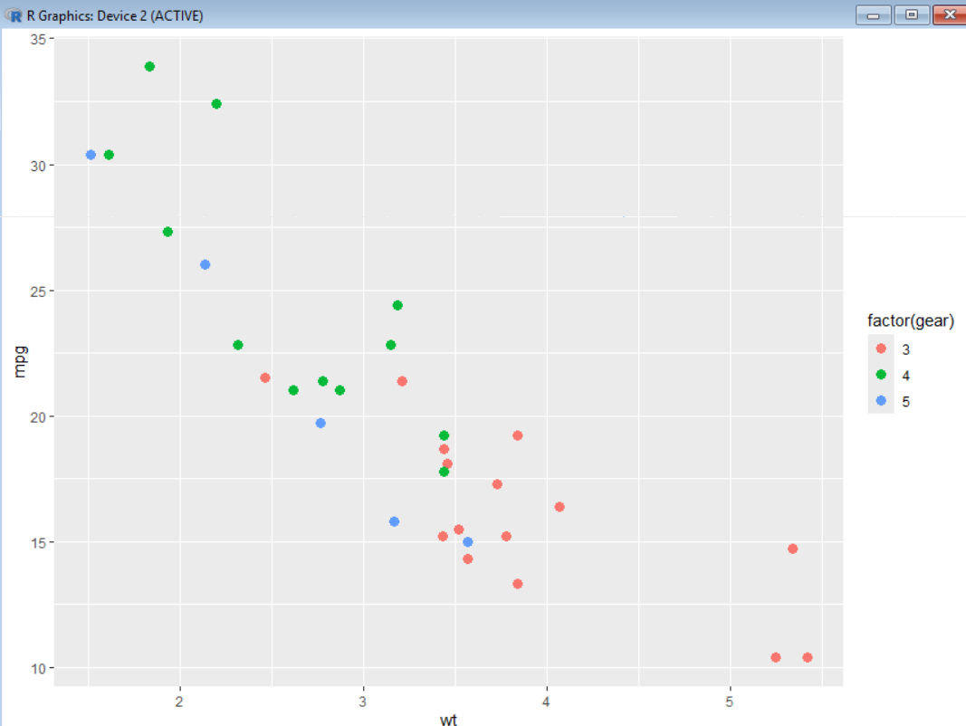
4.Modify color scale
Code:
library(ggplot2)
ggplot(mtcars, aes(wt, mpg, color = factor(cyl))) +
geom_point(size = 3) +
scale_color_manual(values = c("red", "blue", "green"))
output:
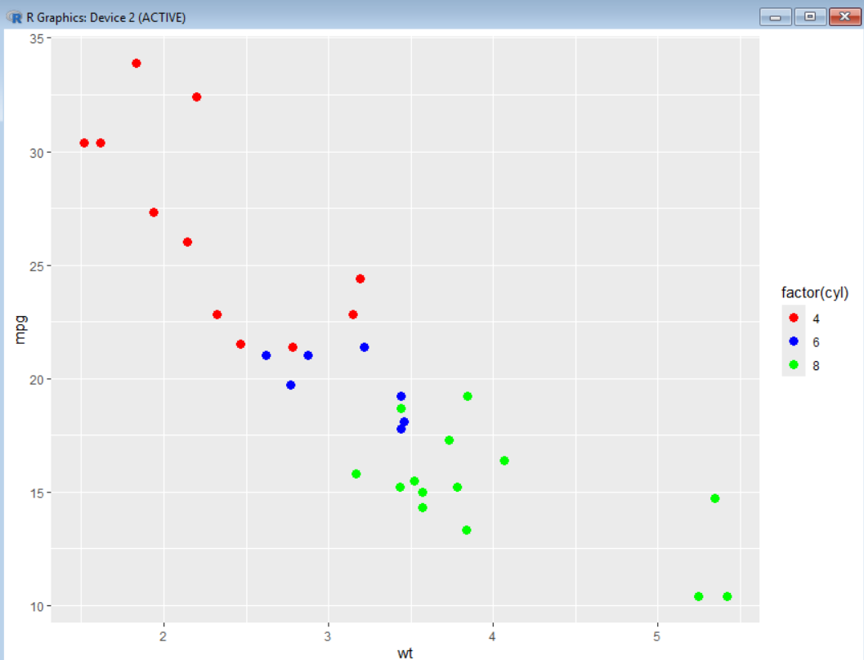
5.Custom breaks
Code:
library(ggplot2)
ggplot(mtcars, aes(wt, mpg)) +
geom_point() +
scale_x_continuous(breaks = seq(1, 6, 1))
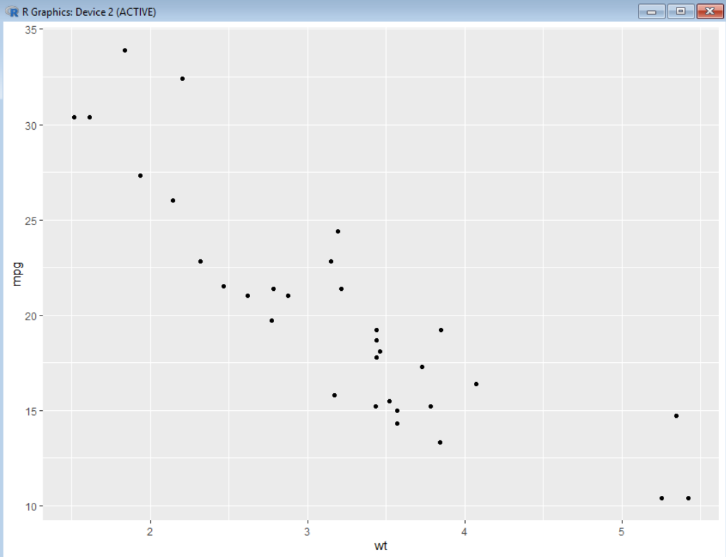
6.Cartesian coordinates
Code:
library(ggplot2)
ggplot(mtcars, aes(wt, mpg)) +
geom_point(size = 3) +
coord_cartesian(xlim = c(1.5, 5.5), ylim = c(10, 35))
output:
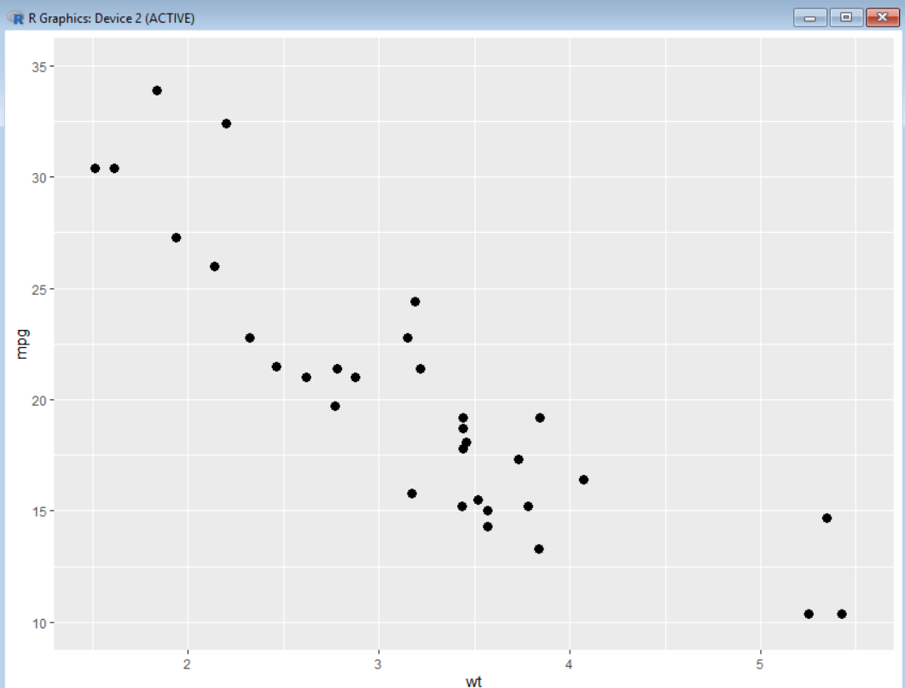
7.Non linear axes
Code:
library(ggplot2)
ggplot(mtcars, aes(wt, mpg)) +
geom_point() +
scale_x_log10() +
scale_y_log10()
output:
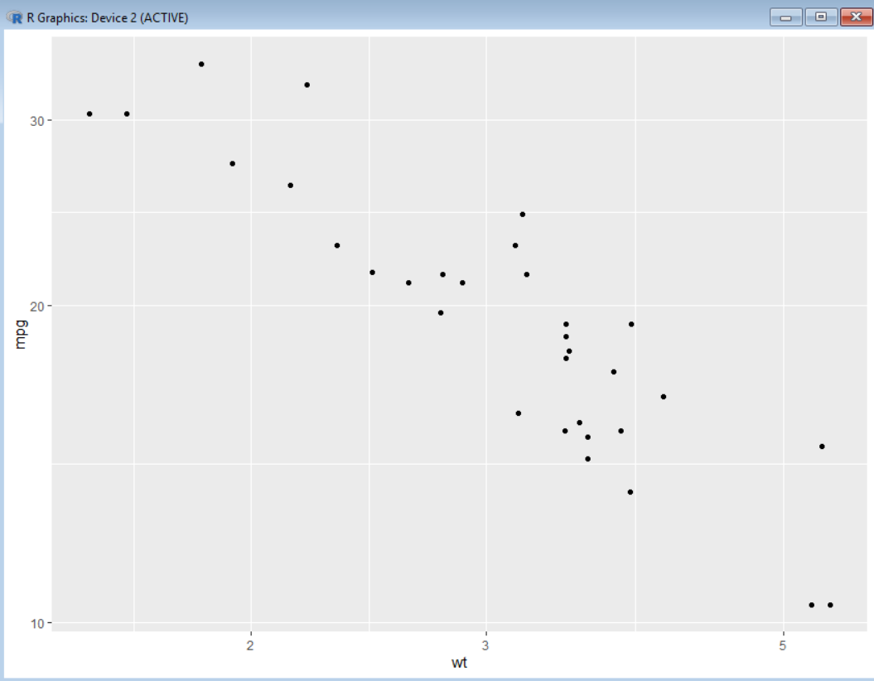
8.log scale example
Code:
library(ggplot2)
ggplot(mtcars, aes(wt, mpg)) +
geom_point() +
scale_x_log10() +
scale_y_log10()
output:
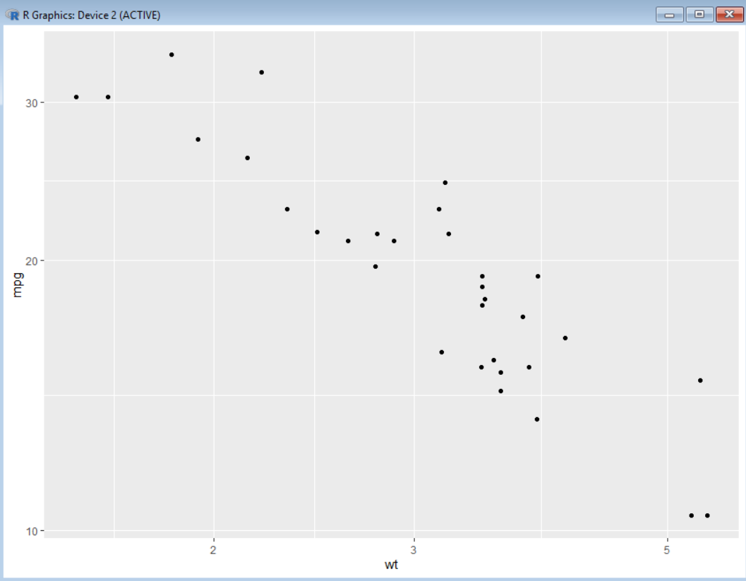
9.polar coordinates
Code:
library(ggplot2)
ggplot(mtcars, aes(x = factor(gear), fill = factor(cyl))) +
geom_bar() +
coord_polar()
output:
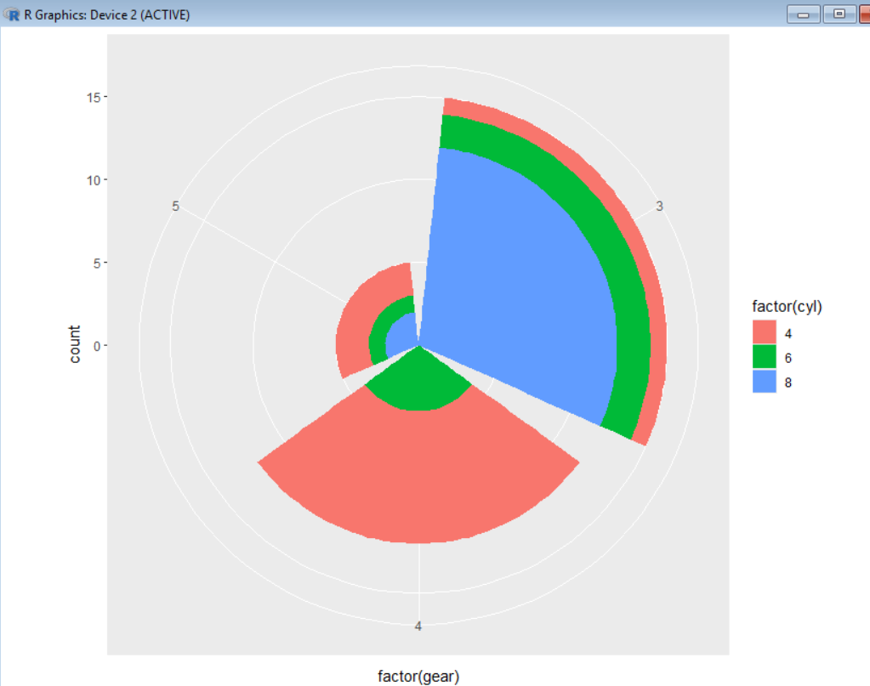
10.sequential color
Code:
library(ggplot2)
ggplot(mtcars, aes(wt, mpg, color = hp)) +
geom_point(size = 3) +
scale_color_gradient(low = "lightblue", high = "darkblue")
output:
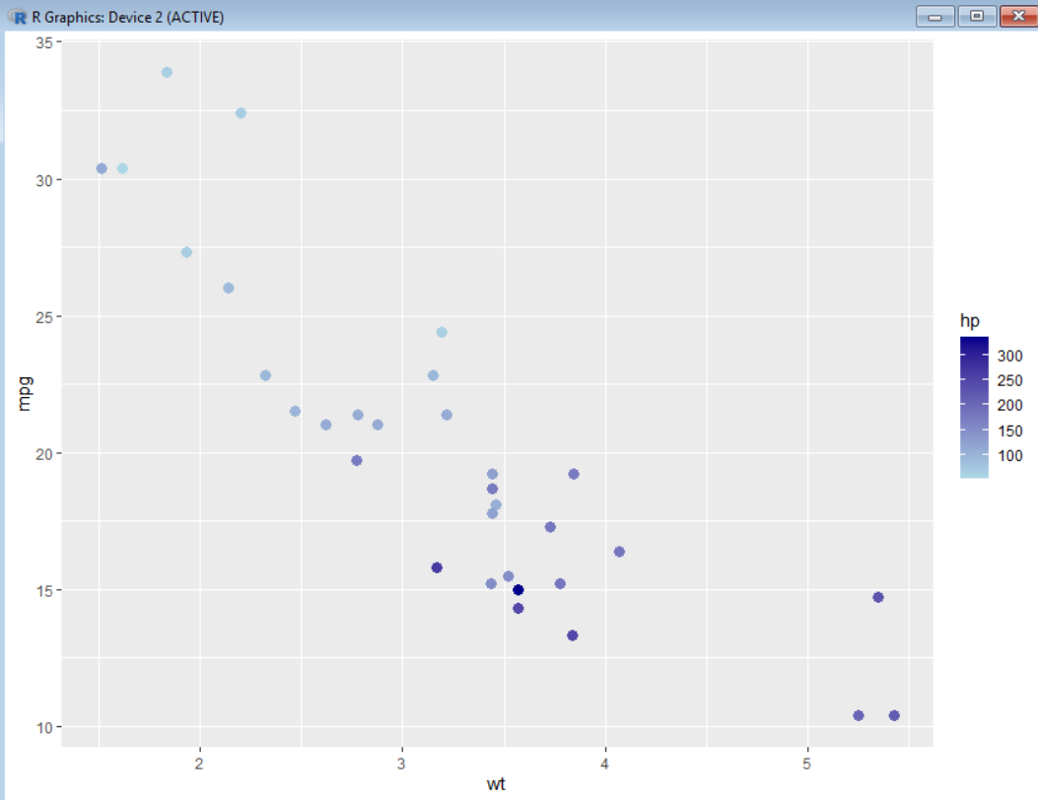
11.Diverging color
Code:
library(ggplot2)
ggplot(mtcars, aes(wt, mpg, color = hp)) +
geom_point(size = 3) +
scale_color_gradient2(low = "blue",
mid = "white",
high = "red",
midpoint = 150)
output:
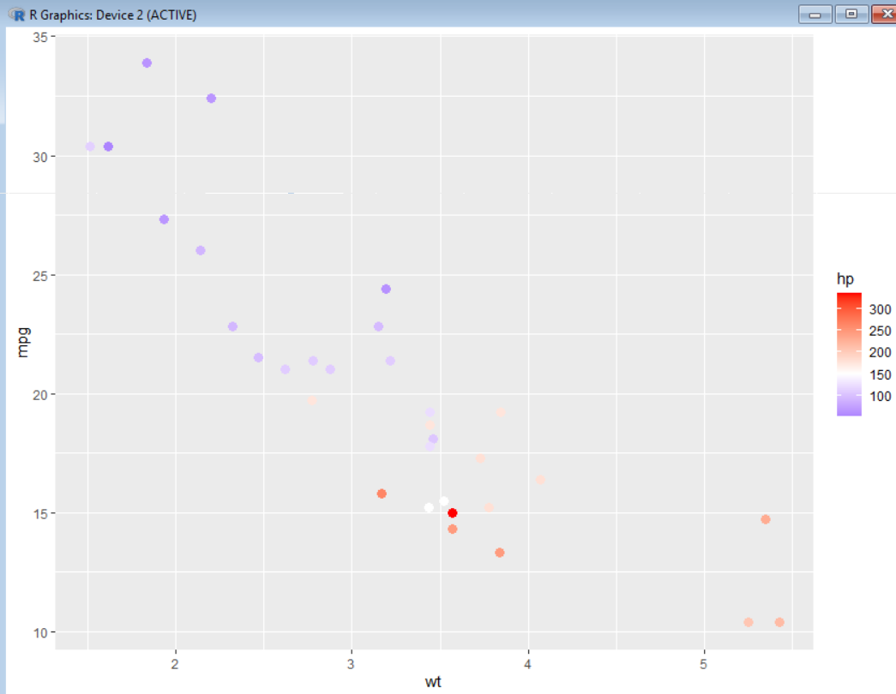
12.Color as a tool distinguish
Code:
library(ggplot2)
ggplot(mtcars, aes(wt, mpg, color = factor(cyl))) +
geom_point(size = 3)
output:
